MIRC Digital Literacy – More Practice Exercises and Resources
Intro to Mouse, Keyboard and Screen

MIRC Digital Literacy Main Menu:
http://www.bit.ly/mircmenu

Mouse Practice:
You can get more practice using a mouse, keyboard and computer screen. Here are some tools you can use. If you do not have an Internet connection, you can find tools on your local computer.

Look for games installed on your local computer. You may think it’s silly to sit and play computer games. But, these games were created to give you practice using a mouse, keyboard and computer screen. They are a fun way for you to practice computer skills.
To find games on your computer:
- click the Windows Start Button Orb on the lower left corner of your screen (in the task bar): 

- Look for the word Games on the right side of the menu. 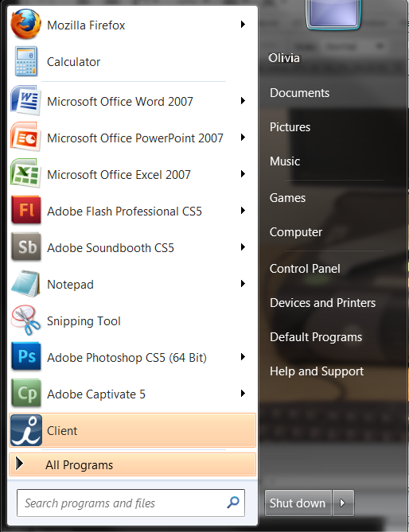

If you do not see the word Games in the menu, click “All Programs” at the bottom of the Start Menu. Then use your mouse to scroll down until you see the word “Games.” Click Games to see a menu of games available on your system. Click on a game to start it. Click “Help,” then “View Help” to get instructions on how to play a game. Try these games:

- Chess (teaches left-clicking and strategy)
- Mahjong (teaches left-clicking, strategy and ‘attention to detail’)
- Solitaire (teaches click and drag, and strategy)
- FreeCell (click and drag, and strategy)

If you do have Internet access, have a teacher, librarian, or someone else help you access these online tools to improve your mousing skills:
Online Mouse Practice:
http://www.pbclibrary.org/mousing/mousercise.htm
http://tech.tln.lib.mi.us/tutor/

